**Kickstart Campaigns: The Path to Success**

Kickstarter campaigns are a way for creative projects to get off the ground by crowdsourcing their funding. The company claims its platform enables all organizations, from the small and unknown to the large and popular, fund their projects while maintaining creative control by connecting the campaigners to their audience. But not all Kickstarter campaigns succeed. What is the characteristic or group of characteristics that determines success in a Kickstarter campaign?

**The Effect of Backers**

Given our data of 4,000 Kickstarter campaigns, 56% of concluded* campaigns were successful, while 46% either failed (38%) or were canceled (8.5%). Successful campaigns had an average of 194 financial backers, while failed campaigns had an average of 18. From this we are inclined to infer that, on average, successful campaigns recruited more backers. However, the standard deviation for successful campaigns (844.3) was much larger than for failed ones (61.43), suggesting that the number of backers per successful campaign is much more widely varied, and therefore many successful campaigns may not resemble the average.

The raw data also reveals that there are two outliers at the top of the numbers for backers of successful campaigns: The data jumps from 5812, 8200 and 8359 backers to 20,242 and 26,457 backers. Since these two campaigns produced so many more backers than the other 2183 campaigns’ numbers, I removed them from the data set and calculated the new mean as 173.21 and the new standard deviation as 461.5 for number of backers of successful campaigns. The new standard deviation is much lower after eliminating the outliers, but still much higher than the standard deviation of the failed campaigns. (For the rest of the data calculations, I kept the outliers in the calculations.)

**The Effect of Donations and Goals**

We can see that successful campaigns on average have a larger number of backers, yet still more than half (66%) of those successful campaigns had fewer than 100 financial backers each. Could there be another element besides number of backers that influences the success of a Kickstarter campaign, such as average donation? After all, a campaign with five backers contributing $1,000 each would surpass a campaign with a thousand backers contributing $1 each in terms of total money collected. Or maybe the amount of money seeking to be raised has an effect: Perhaps it’s just easier to have a successful campaign if the monetary goal is below a certain threshold.

To check for these possible correlations, I made two additional statistical summaries**: One comparing the average donation of successful campaigns versus failed ones, and another comparing the average goal of the campaigns:

Clearly, the average goal of the failed campaigns was much higher than that of the successful ones. This information supports the line chart found in the Bonus 1 worksheet that depicts the successes trending downward and the failures trending upward as the monetary goal of the campaign rises. Perhaps the failed campaigns were too ambitious. But does this mean large-number goals scare away backers, or is there a certain dollar amount beyond which it is difficult to raise funds with a Kickstarter campaign? Or something else entirely? We cannot answer these questions from the data available.

**The Effect of Categories**

However, there are other factors we can consider. Different categories saw significantly more success than others. Here’s how it breaks down:

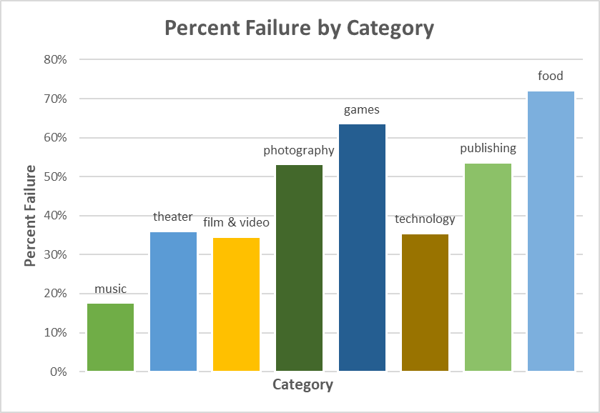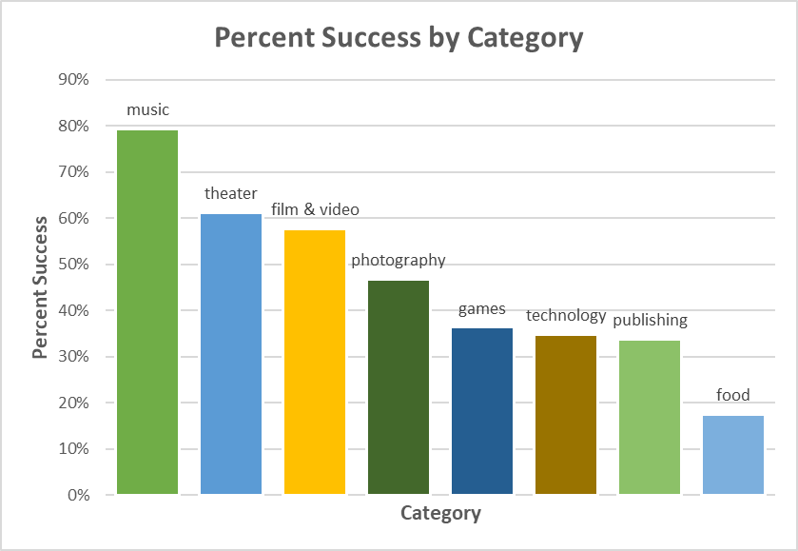

As you can see, the top three most successful categories were Music with 79% of its campaigns returning successful, Theater with 61% and Film and Video with 58%. What we cannot know from this information is *why* a particular category found more success than others. We can consider the possibility that the categories that saw more success asked for less money on average, per our findings about the average goal’s effect on success. However, broken into categories, we see that particular trend doesn’t always hold true: Music, the most successful category, is indeed low in its average goal ($6970) compared to the other categories, but Film & Video ($265,947) and Theater ($120,119) were the top one and two for average goal, respectively. So there may be factors at play that our data doesn’t cover: Could it be a matter of music fans being more philanthropic, or maybe music fans on average tend to have more disposable income? Perhaps there is a commonality in the way musicians conduct their Kickstarter campaigns that causes them to see better success?

**But Wait, There’s More…**

There are some other angles we could consider when trying to decipher the cause and effect of successes or failures in a Kickstarter campaign. First, I’d create line graphs to measure goal size versus success by category to see if the overall trend that we found in our line graph that considered the same information across all categories holds true within a category. If it did, I’d examine the data in the Music category to see if there was a factor that was different from the next two successful categories that may have helped it to overcome the limitations that the goal size seems to put on success. I’d also drill down into the Music category to see if the success rate of the parent category is owing to one particular sub-category, or if the success rate is consistent through each sub-category. I’d also use a pivot table for this, and I’d make a bar chart depicting the number of successes per sub-category. Other possible avenues to explore would be the effect of country of origin, currency used, and length of time on success rates. To measure this, I’d use a pivot table and produce column charts for each of those features to see if a cause/effect relationship can be seen. And finally, I’d re-calculate the average donation, average goal and percent success by category with the outliers removed from the number of backers of successful campaigns.